Mohammad Jawad Rezaei ID: 8351

Student Grading System

Activity_main.xml codes:

<?xml version="1.0" encoding="utf-8"?>

<android.support.constraint.ConstraintLayout xmlns:android="http://schemas.android.com/apk/res/android"

xmlns:app="http://schemas.android.com/apk/res-auto"

xmlns:tools="http://schemas.android.com/tools"

android:layout_width="match_parent"

android:layout_height="match_parent"

tools:context=".MainActivity"

tools:layout_editor_absoluteY="81dp">

<TextView

android:id="@+id/textView"

android:layout_width="0dp"

android:layout_height="0dp"

android:layout_marginBottom="18dp"

android:layout_marginEnd="27dp"

android:layout_marginLeft="27dp"

android:layout_marginRight="27dp"

android:layout_marginStart="27dp"

android:layout_marginTop="19dp"

android:text="Student Grading System"

android:textColor="@android:color/black"

android:textSize="30sp"

app:layout_constraintBottom_toTopOf="@+id/studetnid"

app:layout_constraintEnd_toEndOf="parent"

app:layout_constraintStart_toStartOf="parent"

app:layout_constraintTop_toTopOf="parent" />

<TextView

android:id="@+id/textView2"

android:layout_width="0dp"

android:layout_height="0dp"

android:layout_marginBottom="187dp"

android:layout_marginEnd="26dp"

android:layout_marginLeft="16dp"

android:layout_marginRight="26dp"

android:layout_marginStart="16dp"

android:layout_marginTop="76dp"

android:text="Student ID"

android:textSize="24sp"

app:layout_constraintBottom_toTopOf="@+id/idTextView"

app:layout_constraintEnd_toStartOf="@+id/studetnid"

app:layout_constraintStart_toStartOf="parent"

app:layout_constraintTop_toTopOf="parent" />

<TextView

android:id="@+id/textView3"

android:layout_width="0dp"

android:layout_height="0dp"

android:layout_marginBottom="10dp"

android:layout_marginEnd="20dp"

android:layout_marginLeft="16dp"

android:layout_marginRight="20dp"

android:layout_marginStart="16dp"

android:text="Course Code"

android:textSize="24sp"

app:layout_constraintBottom_toTopOf="@+id/textView4"

app:layout_constraintEnd_toStartOf="@+id/coursecode"

app:layout_constraintStart_toStartOf="parent"

app:layout_constraintTop_toBottomOf="@+id/studetnid" />

<TextView

android:id="@+id/textView4"

android:layout_width="0dp"

android:layout_height="0dp"

android:layout_marginBottom="10dp"

android:layout_marginEnd="20dp"

android:layout_marginLeft="16dp"

android:layout_marginRight="20dp"

android:layout_marginStart="16dp"

android:text="Total Marks"

android:textSize="24sp"

app:layout_constraintBottom_toTopOf="@+id/button"

app:layout_constraintEnd_toStartOf="@+id/marks"

app:layout_constraintStart_toStartOf="parent"

app:layout_constraintTop_toBottomOf="@+id/textView3" />

<EditText

android:id="@+id/studetnid"

android:layout_width="0dp"

android:layout_height="0dp"

android:layout_marginBottom="9dp"

android:layout_marginEnd="50dp"

android:layout_marginRight="50dp"

android:ems="10"

android:hint="Enter your ID"

android:inputType="number"

android:textSize="18sp"

app:layout_constraintBottom_toTopOf="@+id/textView3"

app:layout_constraintEnd_toEndOf="parent"

app:layout_constraintStart_toEndOf="@+id/textView2"

app:layout_constraintTop_toBottomOf="@+id/textView" />

<EditText

android:id="@+id/coursecode"

android:layout_width="0dp"

android:layout_height="42dp"

android:layout_marginBottom="50dp"

android:layout_marginEnd="44dp"

android:layout_marginRight="44dp"

android:layout_marginTop="52dp"

android:ems="10"

android:hint="Enter course code"

android:inputType="textCapCharacters"

app:layout_constraintBottom_toBottomOf="@+id/marks"

app:layout_constraintEnd_toEndOf="parent"

app:layout_constraintStart_toEndOf="@+id/textView3"

app:layout_constraintTop_toTopOf="@+id/studetnid" />

<EditText

android:id="@+id/marks"

android:layout_width="0dp"

android:layout_height="wrap_content"

android:layout_marginBottom="5dp"

android:layout_marginEnd="44dp"

android:layout_marginRight="44dp"

android:ems="10"

android:hint="Enter your Marks"

android:inputType="number|numberDecimal"

app:layout_constraintBottom_toTopOf="@+id/button"

app:layout_constraintEnd_toEndOf="parent"

app:layout_constraintStart_toEndOf="@+id/textView4" />

<Button

android:id="@+id/button"

android:layout_width="wrap_content"

android:layout_height="wrap_content"

android:layout_marginBottom="26dp"

android:layout_marginEnd="10dp"

android:layout_marginRight="10dp"

android:text="SHOW GRADE"

app:layout_constraintBottom_toTopOf="@+id/studentidshow"

app:layout_constraintEnd_toEndOf="@+id/studentidshow"

app:layout_constraintTop_toBottomOf="@+id/textView4" />

<TextView

android:id="@+id/idTextView"

android:layout_width="0dp"

android:layout_height="0dp"

android:layout_marginBottom="10dp"

android:layout_marginEnd="47dp"

android:layout_marginLeft="16dp"

android:layout_marginRight="47dp"

android:layout_marginStart="16dp"

android:textSize="18sp"

app:layout_constraintBottom_toTopOf="@+id/codeTextView"

app:layout_constraintEnd_toStartOf="@+id/studentidshow"

app:layout_constraintStart_toStartOf="parent"

app:layout_constraintTop_toBottomOf="@+id/textView2" />

<TextView

android:id="@+id/codeTextView"

android:layout_width="0dp"

android:layout_height="0dp"

android:layout_marginBottom="14dp"

android:layout_marginEnd="42dp"

android:layout_marginLeft="16dp"

android:layout_marginRight="42dp"

android:layout_marginStart="16dp"

android:textSize="18sp"

app:layout_constraintBottom_toTopOf="@+id/markTextView"

app:layout_constraintEnd_toStartOf="@+id/coursecodeshow"

app:layout_constraintStart_toStartOf="parent"

app:layout_constraintTop_toBottomOf="@+id/idTextView" />

<TextView

android:id="@+id/markTextView"

android:layout_width="0dp"

android:layout_height="0dp"

android:layout_marginBottom="19dp"

android:layout_marginEnd="42dp"

android:layout_marginLeft="16dp"

android:layout_marginRight="42dp"

android:layout_marginStart="16dp"

android:textSize="18sp"

app:layout_constraintBottom_toTopOf="@+id/gradeTextView"

app:layout_constraintEnd_toStartOf="@+id/marksshow"

app:layout_constraintStart_toStartOf="parent"

app:layout_constraintTop_toBottomOf="@+id/codeTextView" />

<TextView

android:id="@+id/gradeTextView"

android:layout_width="0dp"

android:layout_height="0dp"

android:layout_marginBottom="10dp"

android:layout_marginEnd="37dp"

android:layout_marginLeft="27dp"

android:layout_marginRight="37dp"

android:layout_marginStart="27dp"

android:textSize="18sp"

app:layout_constraintBottom_toBottomOf="parent"

app:layout_constraintEnd_toStartOf="@+id/grade"

app:layout_constraintStart_toStartOf="parent"

app:layout_constraintTop_toBottomOf="@+id/markTextView" />

<TextView

android:id="@+id/studentidshow"

android:layout_width="0dp"

android:layout_height="0dp"

android:layout_marginBottom="10dp"

android:layout_marginEnd="123dp"

android:layout_marginRight="123dp"

android:textColor="@android:color/black"

app:layout_constraintBottom_toTopOf="@+id/coursecodeshow"

app:layout_constraintEnd_toEndOf="parent"

app:layout_constraintStart_toEndOf="@+id/idTextView"

app:layout_constraintTop_toBottomOf="@+id/button" />

<TextView

android:id="@+id/coursecodeshow"

android:layout_width="0dp"

android:layout_height="0dp"

android:layout_marginBottom="11dp"

android:layout_marginEnd="118dp"

android:layout_marginRight="118dp"

android:textColor="@android:color/black"

app:layout_constraintBottom_toTopOf="@+id/marksshow"

app:layout_constraintEnd_toEndOf="parent"

app:layout_constraintStart_toEndOf="@+id/codeTextView"

app:layout_constraintTop_toBottomOf="@+id/studentidshow" />

<TextView

android:id="@+id/marksshow"

android:layout_width="0dp"

android:layout_height="0dp"

android:layout_marginBottom="16dp"

android:layout_marginEnd="118dp"

android:layout_marginRight="118dp"

android:textColor="@android:color/black"

app:layout_constraintBottom_toTopOf="@+id/grade"

app:layout_constraintEnd_toEndOf="parent"

app:layout_constraintStart_toEndOf="@+id/markTextView"

app:layout_constraintTop_toBottomOf="@+id/coursecodeshow" />

<TextView

android:id="@+id/grade"

android:layout_width="0dp"

android:layout_height="0dp"

android:layout_marginBottom="7dp"

android:layout_marginEnd="124dp"

android:layout_marginRight="124dp"

android:textColor="@android:color/holo_green_dark"

android:textSize="18sp"

android:textStyle="bold"

app:layout_constraintBottom_toBottomOf="parent"

app:layout_constraintEnd_toEndOf="parent"

app:layout_constraintStart_toEndOf="@+id/gradeTextView"

app:layout_constraintTop_toBottomOf="@+id/marksshow" />

</android.support.constraint.ConstraintLayout>

**Design:**

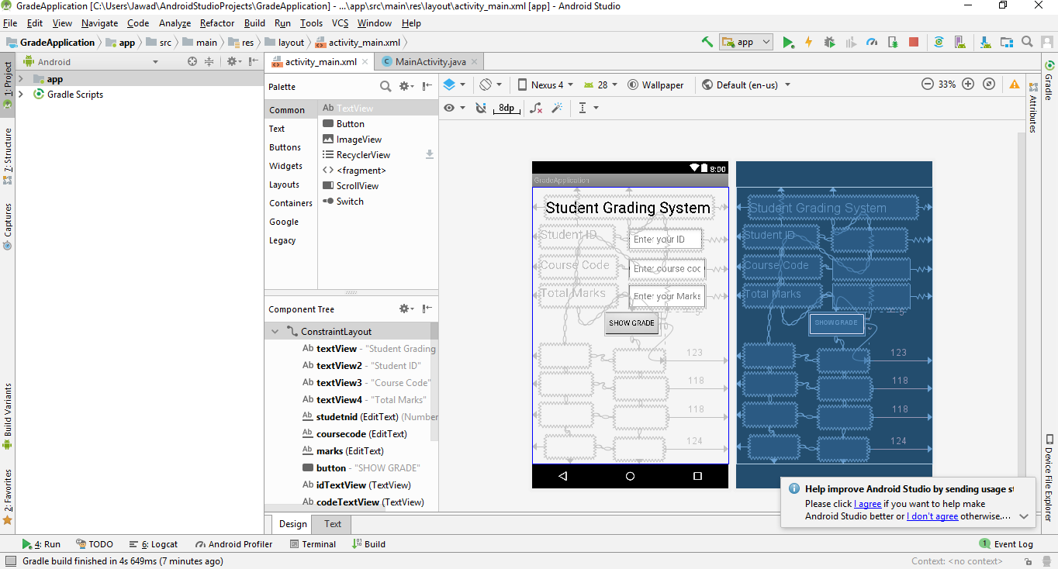

**JAVA CODES:**

package com.example.itcs.gradeapplication;

import android.os.Bundle;

import android.support.v7.app.AppCompatActivity;

import android.view.View;

import android.widget.Button;

import android.widget.EditText;

import android.widget.TextView;

public class MainActivity extends AppCompatActivity {

@Override

protected void onCreate(Bundle savedInstanceState) {

super.onCreate(savedInstanceState);

setContentView(R.layout.activity_main);

Button calcbutton = (Button) findViewById(R.id.button);

calcbutton.setOnClickListener(new View.OnClickListener() {

@Override

public void onClick(View v) {

EditText id = (EditText) findViewById(R.id.studetnid);

EditText code = (EditText) findViewById(R.id.coursecode);

EditText mark = (EditText) findViewById(R.id.marks);

TextView idshow = (TextView) findViewById(R.id.studentidshow);

TextView codeshow = (TextView) findViewById(R.id.coursecodeshow);

TextView markshow= (TextView) findViewById(R.id.marksshow);

TextView gradeshow = (TextView) findViewById(R.id.grade);

TextView idtextview = (TextView) findViewById(R.id.idTextView);

TextView codetextview = (TextView) findViewById(R.id.codeTextView);

TextView marktextview = (TextView) findViewById(R.id.markTextView);

TextView gradetextview = (TextView) findViewById(R.id.gradeTextView);

int studentid = Integer.parseInt(id.getText().toString());

String codeid = code.getText().toString();

float studentmark = Float.parseFloat(mark.getText().toString());

idshow.setText(studentid + "");

codeshow.setText(codeid + "");

markshow.setText(studentmark + "");

idtextview.setText("Student ID: ");

codetextview.setText("Course ID: ");

marktextview.setText("Total Marks: ");

gradetextview.setText("Grade: ");

if (studentmark >= 94) {

gradeshow.setText("A");

}

else if (studentmark >= 90) {

gradeshow.setText("A-");

}

else if (studentmark >= 87) {

gradeshow.setText("B+");

}

else if (studentmark >= 84) {

gradeshow.setText("B");

}

else if (studentmark >= 80) {

gradeshow.setText("B-");

}

else if (studentmark >= 77) {

gradeshow.setText("C+");

}

else if (studentmark >= 74) {

gradeshow.setText("C");

}

else if (studentmark >= 70) {

gradeshow.setText("C-");

}

else if (studentmark >= 67) {

gradeshow.setText("D+");

}

else if (studentmark >= 60) {

gradeshow.setText("D");

}

else {

gradeshow.setText("F");

}

}

});

}

}

**Demo 1:**

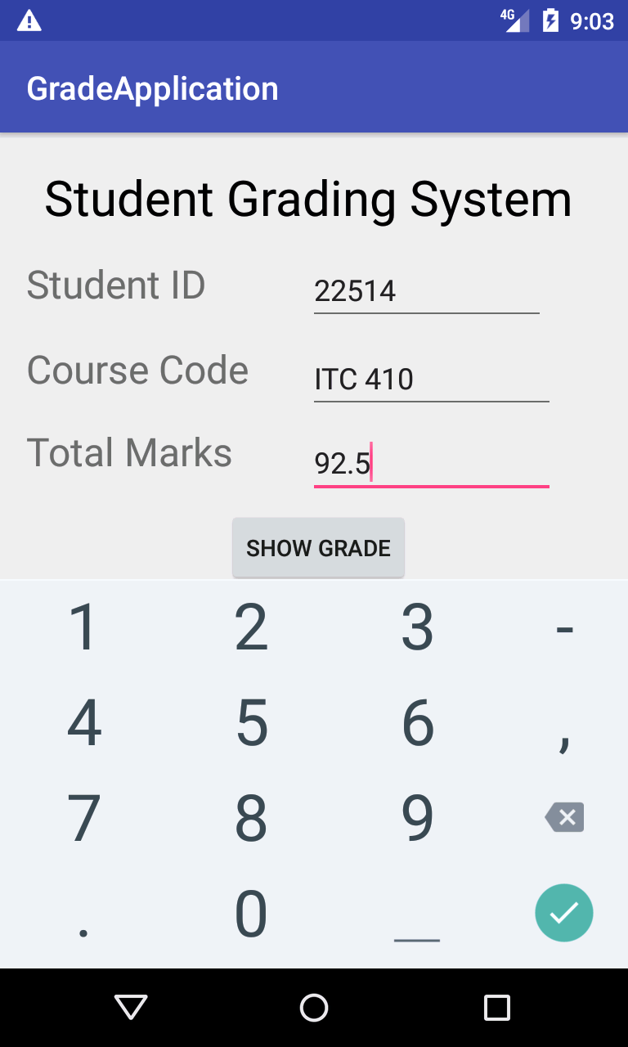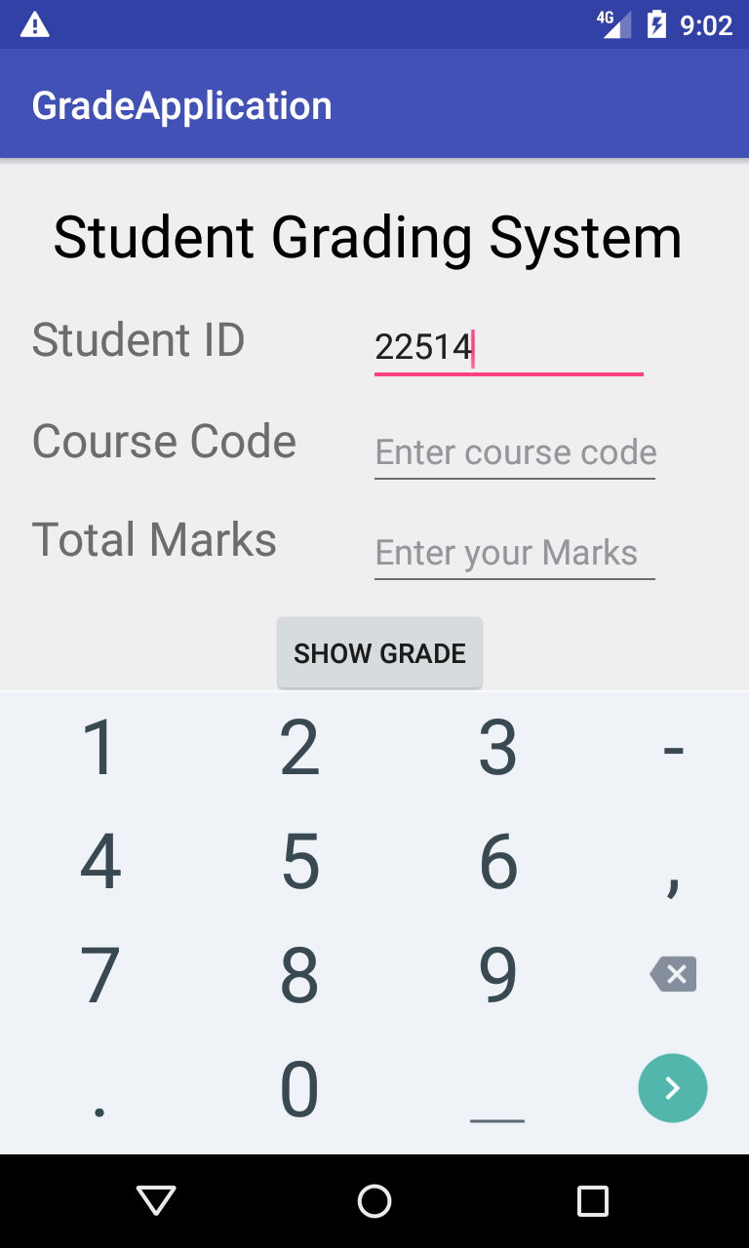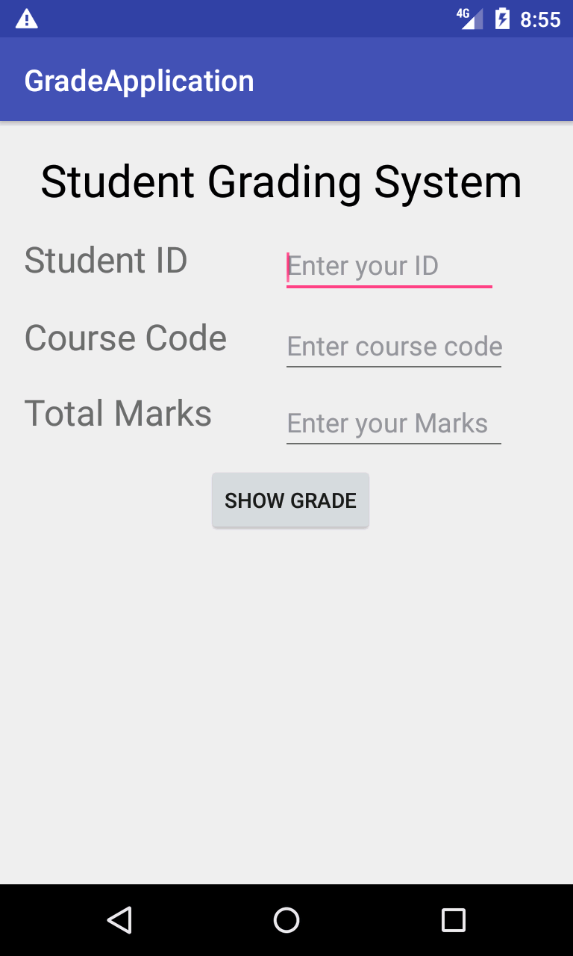

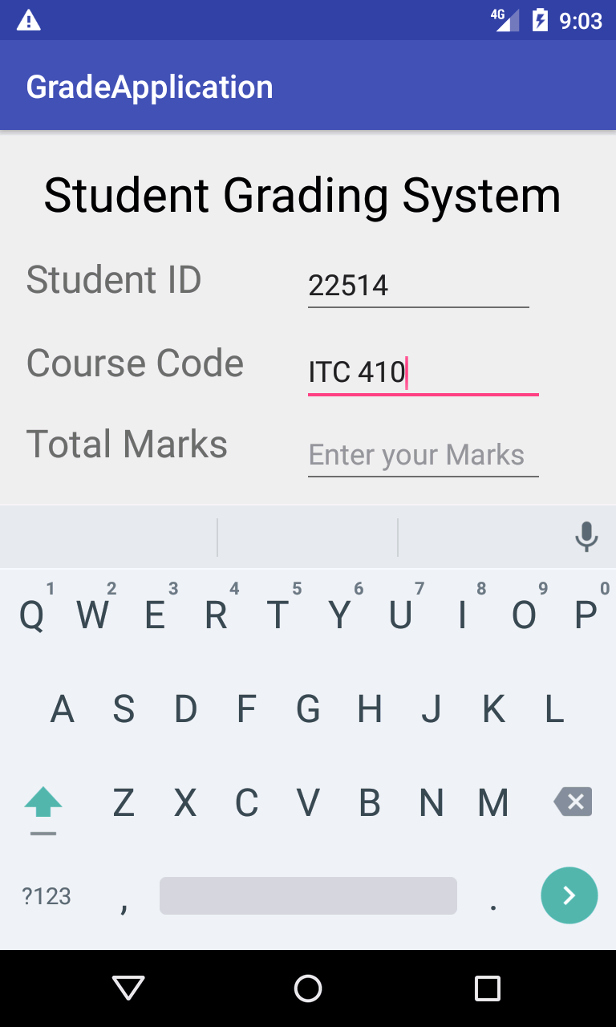

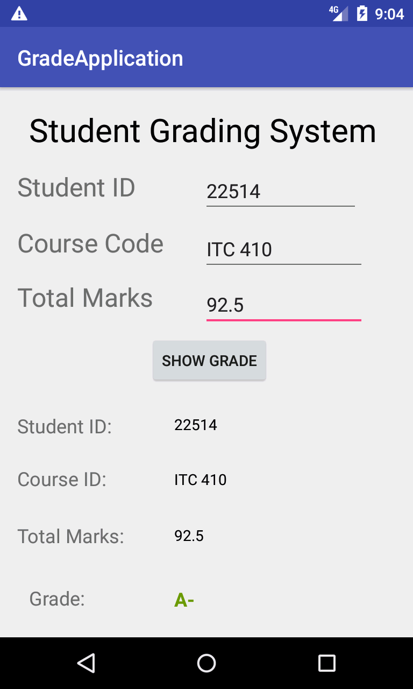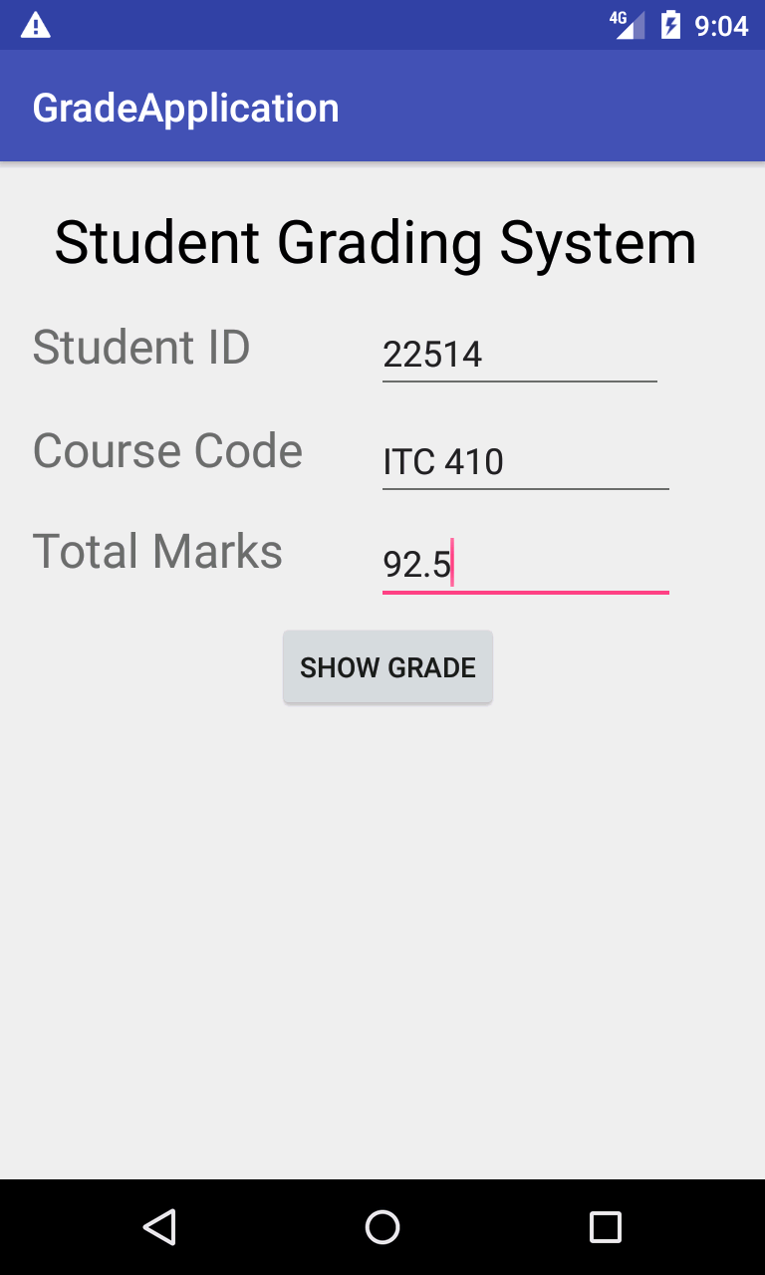

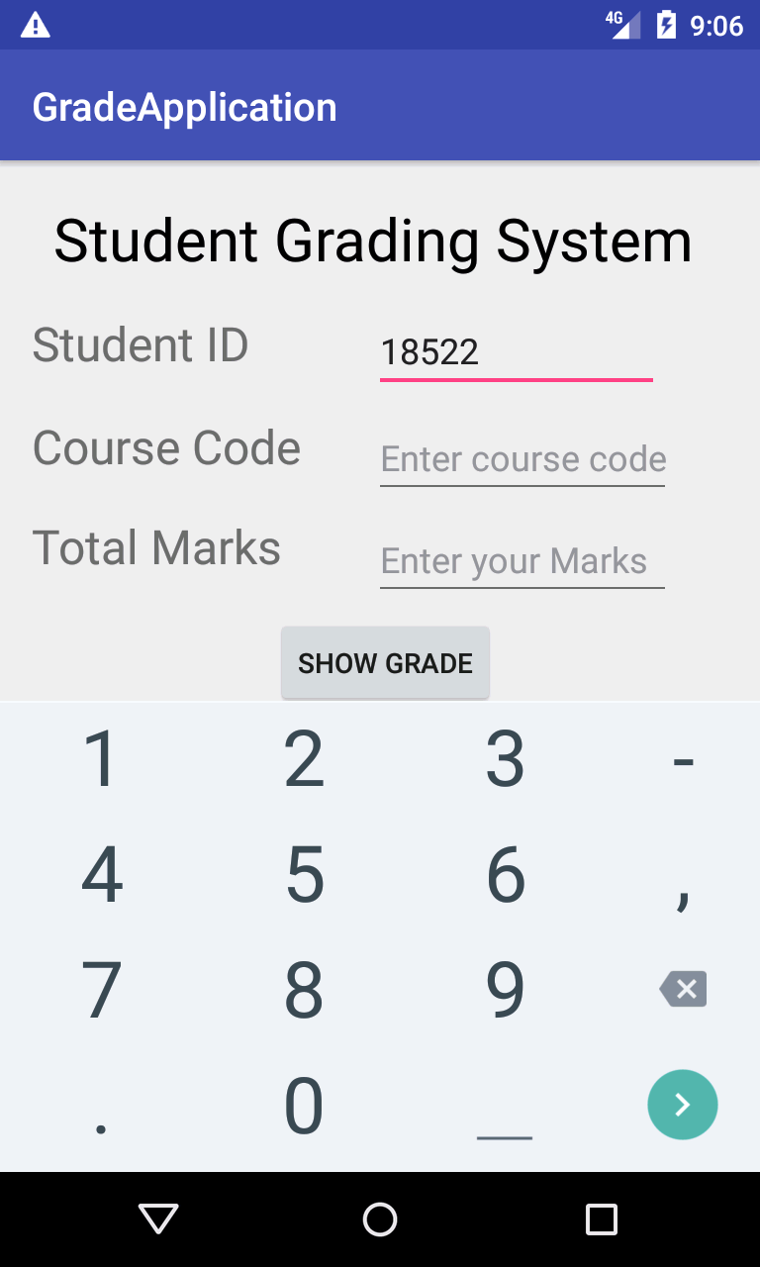**Demo 2**:

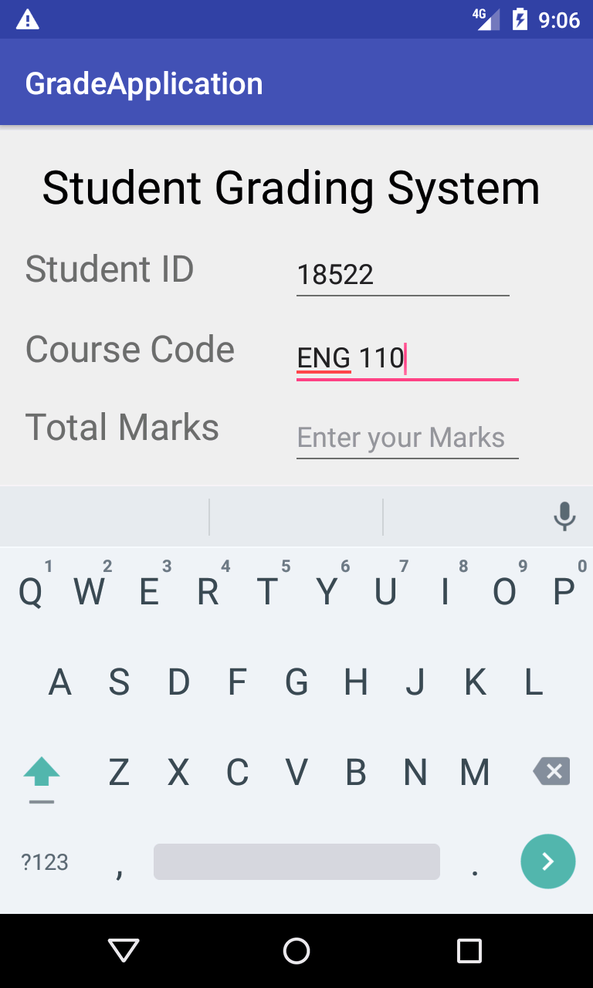

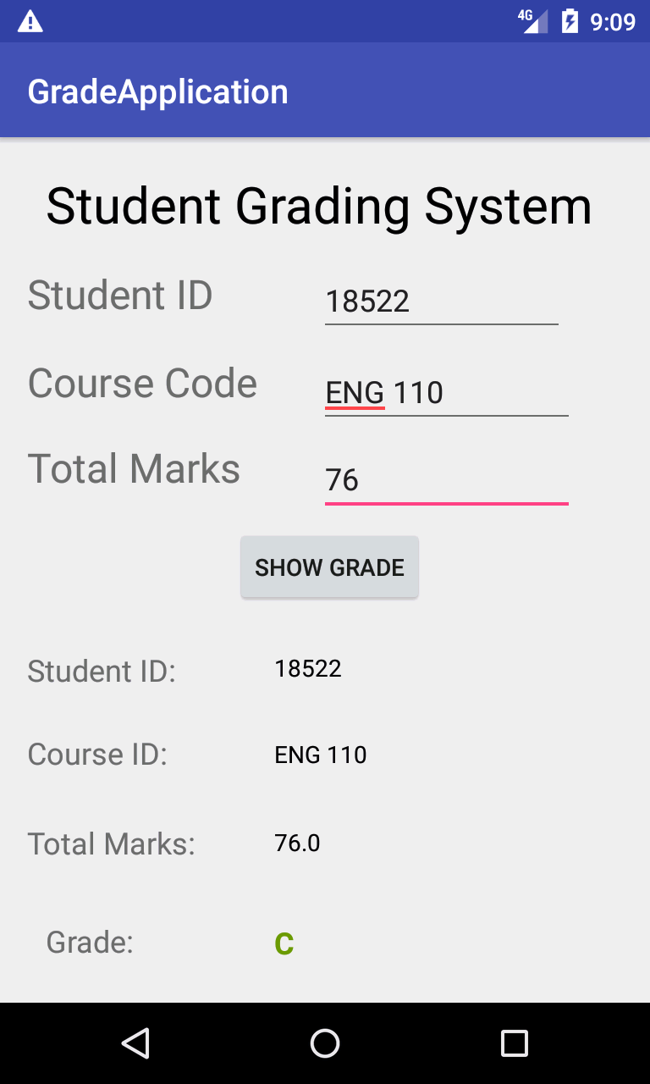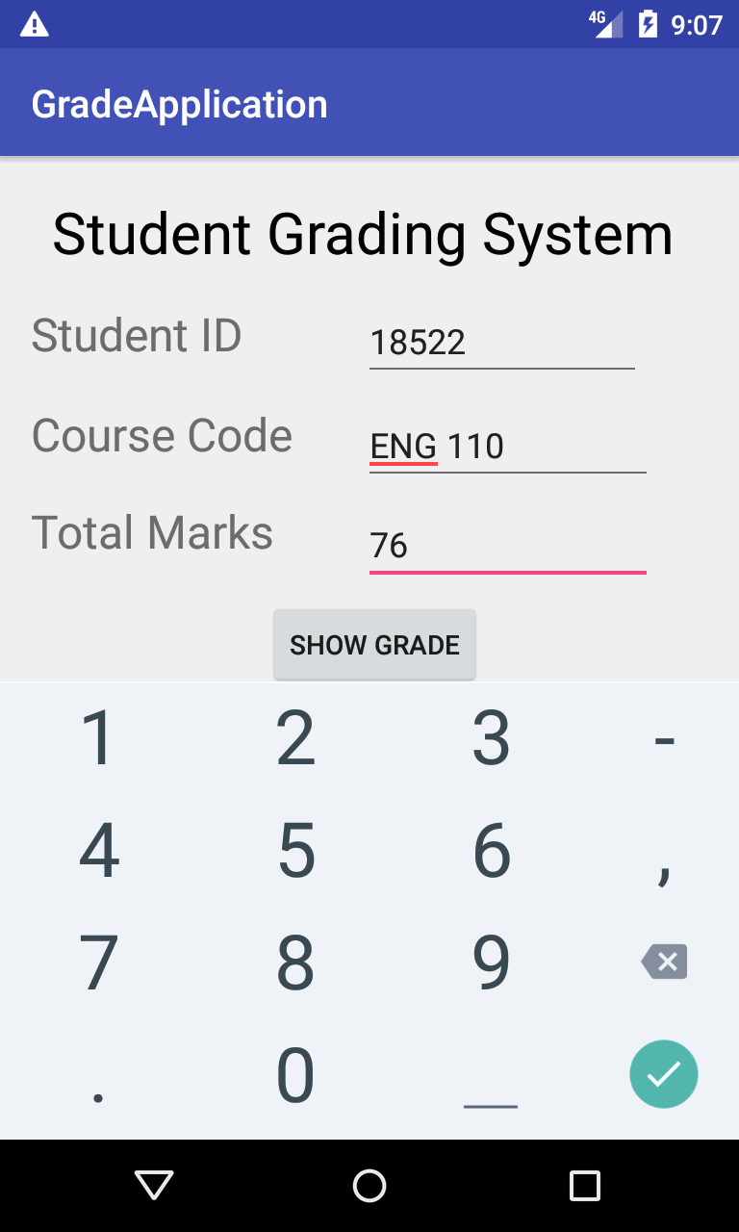

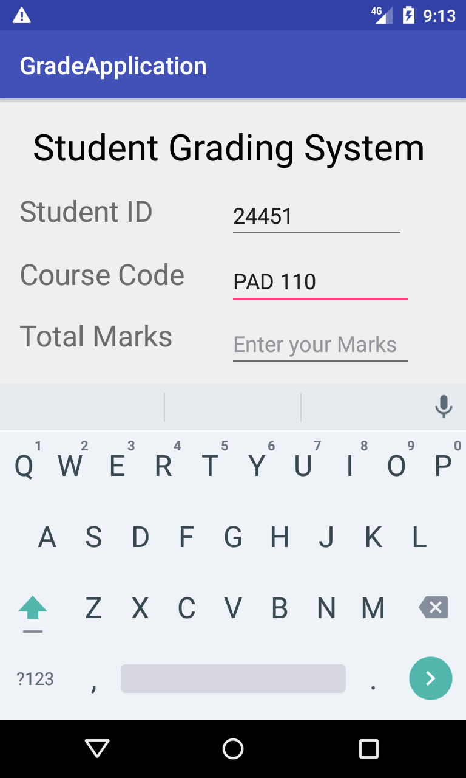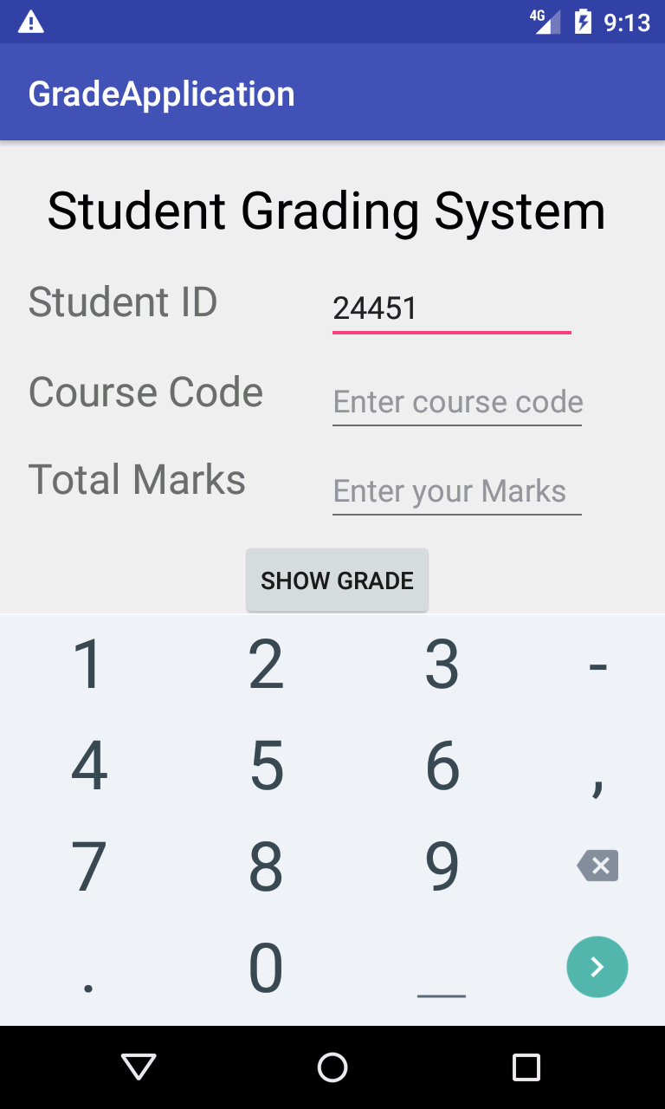**Demo 3:**

